PP Case Study

Student Name: Addison Babcock User ID (###) 036

Date: November 15, 2016

|  |  |
| --- | --- |
| **Description** | **Your Data** |
| Routing Group Number (p7) | 50000652 |
| Operations Plan Version Number (p10) | A00 |
| Question Answer (p15) | From the product group on page 9. |
| Production Order Number (p23) | 1000021 |
| Material Document Number (p25) | 4900002137 |
| Note number of bikes from “Qty in UnE” (p27) | 161 |
| Material Document Number p(28) | 4900002138 |
| Material Document Number (p34) | 5000000109 |
| Report Group Number (p37) | 000001000021 |

Insert screen shot (or cut-out image) of the Production Order Status (p30) as shown in the sample below:

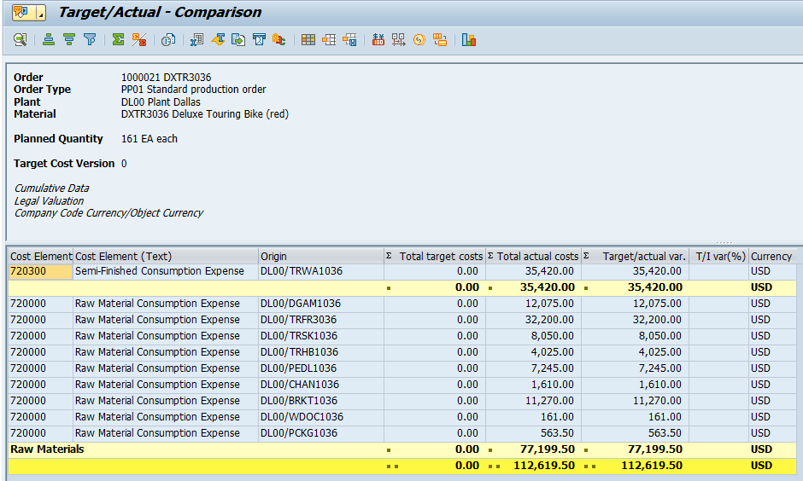

Insert screen shot (or cut-out image) of the Production Order Status (p38) as shown in the sample below:

